MODERN SCHOOL
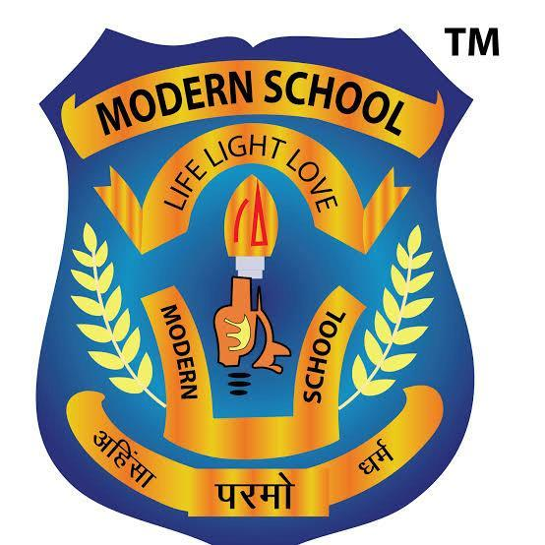
SYLLABUS for CLASS XII (Chemistry -043 ) 2025-26

BOOK PRESCRIBED: CHEMISTRY A TEXT BOOK FOR CLASS XII Part 1 & 2 ( NCERT)
Comprehensive Chemistry Activities-XII Vol-1 & 2( Laxmi Publications P. Ltd.)
Month | L. No. | CHAPTER/LESSON
March | 1. | Solutions
APRIL | 1.  2. | (cont..)Solutions  Electrochemistry(upto nernst equations)
MAY | 2.  3. | (cont…) Electrochemistry  Chemical Kinetics
JULY | 6.  7. | Haloalkanes and Haloarenes  Alcohols, phenols and ethers
AUGUST | 8.  9.  10. | Aldehyde, ketones and Carboxylic acid  Amines  Biomolecules
SEPTEMBER |  | Revision and Ist Term
OCTOBER | 4.  5. | d and f block elements  Coordination Compounds
NOVEMBER |  | Revision and Pre-Board 1
DECEMBER |  | Revision and Pre-Board 2
January |  | CBSE Pactical exam

NOTE: Syllabus will be updated with CBSE updation.
TERM SYLLABUS
TERM 1 | MAY | L=1-(SOLUTIONS)
TERM 2 | JULY | L =2(ELECTROCHEMISTRY)  L=3(CHEMICAL KINETICS)
TERM 3 | AUGUST | L=6(HALOALKANES AND HALOARENES)  L=7(ALCOHOLS,PHENOL AND ETHERS)
HALF - YEARLY | SEPTEMBER | CH 1,2,3,6,7,8,9,10
PRE BOARD 1 | NOVEMBER | Full syllabus
PRE-BOARD 2 | DECEMBER | Full syllabus

Prepared by - NITU KAPOOR
Co-ordinator -

